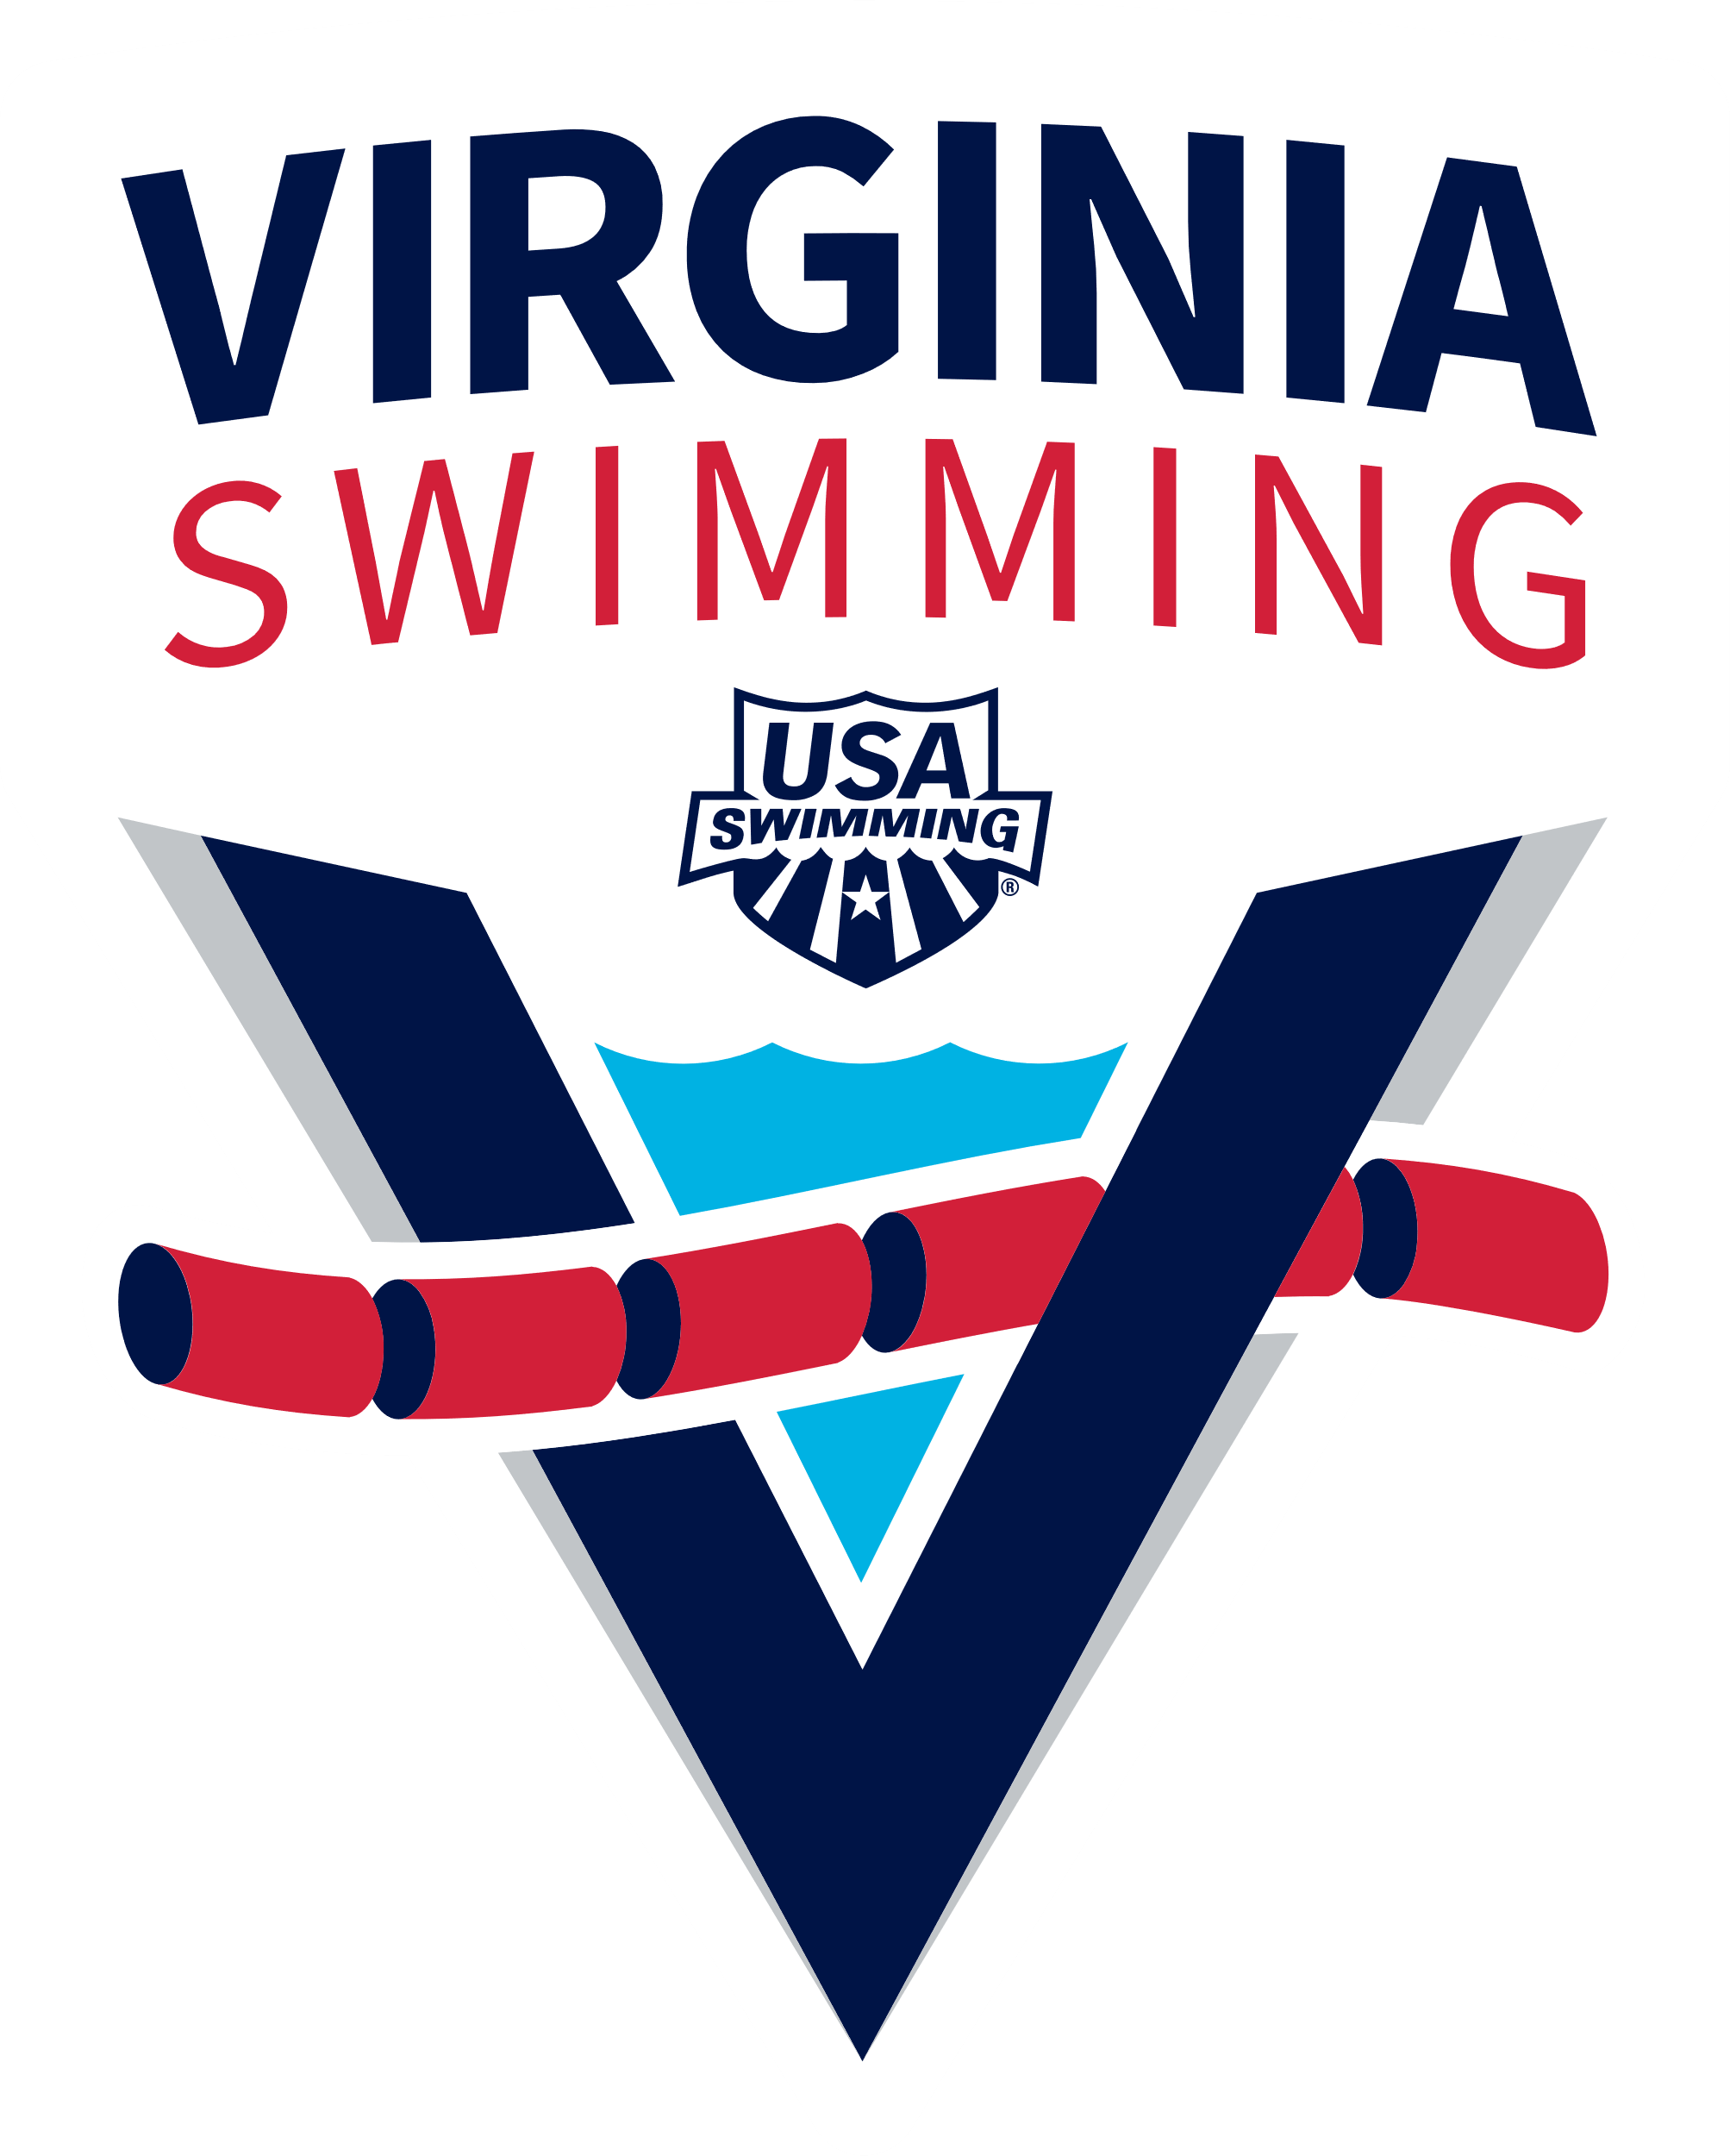 |  | 2026 Lake Montclair Knockout Series October 3rd  SANCTION NO. VS-26- OW  Register Here: | Hosted by  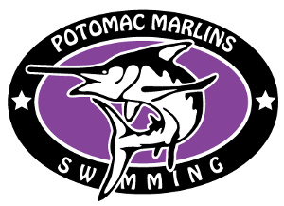
SANCTION: | - Held under the sanction of USA Swimming/Virginia Swimming, Inc., SANCTION NO: VS-26- OW33011206  - USA Swimming Inc., Virginia Swimming, Inc. Potomac Marlins, volunteers, and the Montclair Property Owners Association shall be held free and harmless from any and all liabilities or claims for damages arising by reason of injuries to anyone during the conduct of this event.  In applying for this sanction, Potomac Marlins, agrees to comply and to enforce all health and safety mandates and guidelines of USA Swimming, Virginia Swimming, the Commonwealth of Virginia and County of Prince William.
LOCATION: | 4398 Spillway Lane. Montclair, VA 22025  Parking at Moncure Park (see below)
COURSE DESCRIPTION | Open water: The racecourses: marked with orange turn buoys and yellow sighting buoys. There will be in water start and a beach finish. A yellow finish banner marks the finish line. A pace clock will be used for overall time and manual watches used for a backup system.  This is a fresh water lake swim with 2 different courses.  1.5K (triple loop course), 1K (double loop course), and 500m course (single loop) will be separated by waves. The course is 500m in length.  - Details of racecourse with landmarks are available below (page __)  - Expected water temperature is 68- 75 degrees. Water depth is from 0-58 feet.  - The course is set; however, the race committee reserves the right to change the configuration and/or direction of each event due to race day conditions. The details of races with landmarks are attached. Any questions about the course will be addressed at the pre-race meeting.
MEET DIRECTOR & Event Staff: | Meet Director: Christine Haslem christine.haslem@gmail.com  Co-meet director: Ryan Krogel ryan.krogel12@gmail.com  Referee: Bill Marlin Bill.Marlin@verizon.net  Entry Chair: Zach Smith smith.n.zach@gmail.com  Course Referee: Garrett Haslem  Admin Official: Jeff Chu jeff@hauppaugeswimming.com  Independent Safety Monitor: Jeremiah Johnson civicokaos@yahoo.com  Medical Officer: Alysen Spencer
ELIGIBILITY: | - Open to all USA Swimming athletes age 9 and older.  - Must be a registered USA swimmer to enter. Single day event membership available for an additional $15  - On location, single day event USA Swimming registration will not be permitted.  - Age on October 3, 2026 will determine age for the entire meet.  - Athletes with valid USA Swimming membership may enter until the deadline, September 21 at midnight or until capacity.  Recommended entry standards:  - For 12 and under events, Minimum of B time standard in the 500yd freestyle or the 400M freestyle or successfully completed a minimum of a 500M open water swim in a bay, river, lake or ocean.  - For Knockout Series: Minimum of a 13-14 BB time standard in the 1000yd, 1650yd, 800M, or 1500M freestyle is required. This standard is distinguished by gender. If a swimmer enters this event and did not have the qualifying standard a $50 fine will be charged to the swimmer’s team or if not on a team then to the individual.
DISABILITY SWIMMERS: | - Athletes with a disability are welcomed and shall provide advance notice of desired accommodation(s) to the Meet Director.  - The athlete (or the athlete's coach) is also responsible for notifying the session referee of any disability prior to the competition.
FORMAT: | - Knockout Series:  - 1.5K-(3 loop)  - 1K (2 loops)  - 500M (1-loop)  Race Schedule  3K Knockout Series (qualifying times required)  Round 1: 9:00 AM Male Swimmers Ages 13 & O swim a 1.5K  Round 1: 9:30 AM Female Swimmers Ages 13 & O swim a 1.5K  Round 2: 10 AM Male Swimmers that advanced from round 1 swim a 1K  Round 2: 10:20 AM Female Swimmers that advanced from round 1 swim a 1K  Round 3: 10:40 AM Male swimmers that advanced from round 2 swim 500m  Round 3: 10:50 AM Female swimmers that advanced from round 2 swim 500m  11 am Awards for Knockout Series  1K  Wave 1: 11:30 AM Male Swimmers Ages 13& O  Wave 2: 11:32 AM Female Swimmers Ages 13& O  Wave 3: 11:34 AM Male & Female Swimmers Ages 11-12 (if needed)  Awards for 1K at 12:15 PM  Splash & Dash 500M Swim and 100m run  Wave 1: 1 PM start for all Male Swimmers Ages 9-12  Wave 2: 1:25 PM start for all Female Swimmers Ages 9-12
WARM-UPS: | - Warm-up will be available on the portion of the racecourse closest to the finish area. 8:00 AM-8:30 AM for 3K knockout participants only. Coaches must supervise their athletes during warm-up.  - No warm-downs will be offered.
ENTRIES: | DEADLINE FOR THE RECEIPT OF ENTRIES IS midnight Friday, September 25th.  - Entries must be submitted using the link: Register Here:  - No team entries will be accepted but coaches can email meet director for updates on team entries.  - Swimmers may enter a maximum of 1 individual event.  - Entries will be processed in the order received.

- This meet will be limited to a total of 300 swimmers or maximum of 100 swimmers per event.
- Email entry /website concerns to Christine.haslem@gmail.com

Boys Qualifying Times | Girls Qualifying Times
500y/400m Free- 5:58.19/ 5:23.49 | 500y/400m Free- 6:22.79/ 5:41.79
1000y/800m Free- 12:20.99/ 11:09.19 | 1000y/800m Free- 13:10.29/11:50.79
1650y/1500m Free- 20:46.99/ 21:25.69 | 1650/1500m Free- 22.01.19/22:43.49

FEES: | USA Swimming Members: $75.00 for 3K Knockout Series  USA Swimming Members: $60.00 for 1K and $40 for Splash & Dash  Non-USA Swimming members are required to purchase a One-day ($15) membership in advance of the event and must register through Potomac Valley Swimming.  Residents of Montclair will receive a $10 off discount. Please email the race director for discount code.  No refunds will be given.  Price increases $10 for each event after 9/1.  - Those entering after September 15th 2026 may not receive a T-shirt.
AWARDS: | AWARDS:  3K Awards:  Overall winner for Male & Female  Age Group Awards: 1st-3rd Place Male and Female in each of the following age groups (13-14, 15-18, Open)  1K Awards:  Overall winner for Male & Female  Age Group Awards: 1st-3rd Place Male and Female in each of the following age groups: (11-12, 13-14, 15-18, Open)  Splash & Dash AWARDS:  Overall winner for Male & Female  Age Group Awards: 1st-3rd place Male and Female in the following age groups: 9-10, 11-12  All participants will receive a Montclair Swim Festival bag tag.  - *Awards are subject to change based on the number of participants in each category.
SEEDING: | - Please see the race schedule above for wave times based on gender and age.  - SWIMMERS FAILING TO POSITIVELY CHECK-IN OR NOT ATTEND RACE BRIEFING WILL NOT BE ALLOWED TO SWIM THE EVENT.
PENALTIES: | - A fine of up to $100 per event may be assessed for any illegal participation in the meet. Illegal participation is defined as:  - Entries using fraudulent or non-verifiable times.  - Athletes competed in the incorrect age group.  - Athlete is not registered with USA Swimming prior to the first day of the meet.

- If the swimmer represents a club in competition, the fine will be levied on the Club. If the swimmers are unattached, the fine will be levied on the swimmer.
- Any event in which an athlete participated illegally will be re-scored and re-awarded.
RULES | - The current USA Swimming Rules and Regulations including the Minor Athlete Abuse Protection Policy will govern this meet. Please see Part Seven of the USA Swimming Rules & Regulations for a complete list of Open Water Rules.  - Operation of a drone, or any other flying apparatus, is prohibited over the venue (swimming venue, athlete/coach areas, spectator areas and open ceiling locker rooms) any time athletes, coaches, officials and/or spectators are present without written USA Swimming approval.  - Use of audio or visual recording devices, including cell phones, is not permitted in changing areas, rest rooms or locker rooms.  - Changing, in whole or in part, into or out of swimsuit when wearing just one suit in an area other than in a locker room, bathroom, or other space designated for changing is PROHIBITED.  - An athlete suspected of sustaining a concussion or exhibiting signs of a concussion will immediately be removed from competition and shall not return to competition that day. The athlete may return to competition on a subsequent day, but only with a release authorization signed by a licensed healthcare provider.  - In accordance with VSI Policy, only those coaches who have current, valid USA Swimming credentials will be permitted to act in a coaching capacity at this meet. Coaches with expired or  - non-current credentials will be required to leave the deck area.  - Any swimmer not turning properly at the buoys will be asked to return to the buoy to take the turn properly. Failure to do so will result in the swimmer being disqualified.  - No swimmer shall be allowed to use or wear any device that may be an aid to his/her speed, endurance, or buoyancy.  - A maximum of two (2) caps may be used.  - World Aquatics rules for swimwear will be used for all events  - Swimwear must conform to USA Swimming Rule 701.4. Only swimsuits complying with World Aquatics Open Water swimsuit specifications may be worn in any USA Swimming sanctioned or approved competition.  - Meet Directors may also designate a wetsuit competition category at any event other than Junior National Championships, National Championships, and Zone Open Water Championships.  - Wetsuits (for both men and women) shall not extend beyond the neck, wrists, and ankles. The thickness of material(s) used shall be maximum 5 mm.  This event will likely be wetsuit legal based on the previous year’s combined air and water temperatures.
OFFICIALS: | Meet Referee: Bill Marlin  Email: Bill.Marlin@verizon.net  - Officials at all positions will be required for this meet. Open Water Officials with certification card are welcomed and encouraged to assist. Please complete the form:  - Officials meeting will be at 7:00 AM at the hospitality pavilion.
SAFETY: | The meet is a beach start with swimmers held in a closed area marked by numbers on shoulders, back and horizontally down the arms. They will hold a bag tag with the same number and will give this tag to the chief sweep judge prior to the start of the race. The number of each swimmer will be recorded and delivered to each stroke and turn judge prior to the start of race. There will be instructions of the course and rules of play to swimmers, then the start. At each turn, there will be an accounting of the swimmers by Referees and Turn Judges (2 referees on the water and 3 at turn buoys and 2 on land). Anyone leaving the course will be accounted for and communicated to the Meet Referee. When the swimmers finish it will be a beach finish and the swimmers will again be held in the closed starting area until the cards are returned to each swimmer,  Monitoring Swimmers During Race  - Safety boats will monitor the entire course.  - 5 Lifeguards will be on location, (in the water on paddleboards and the Safety Officer on the land with view of entire 500m courses.  - Medical Services  There will be a First Aid station/ tent available at start/finish area.  - Each official, lifeguard and safety officer will have a radio, each safety station will have a whistle, one radio channel will be devoted to safety. One blast on whistle or one blast on air horn to attract attention then radio explanation of safety needs.  - The Safety Officer will oversee all safety at the event, overseeing lifeguards, EMT’s and swims safety. The safety officer will be in contact with the meet director, officials, lifeguards and EMT’s by radio. The medical officer will communicate as needed with EMTs, athletes, guardians, and safety officer.  - Accounting for swimmers  - Each swimmer will receive a numbered card containing their details, which must be presented prior to entering the water.  - There will be safety stations viewing each swimmer and accounting of each swimmer 5 times each lap as they pass each Referee and Turn Judge on the course.  - This is the most important duty of the safety team.  - Each Referee official will follow radio protocol and also radio when last swimmer passes their station each lap.  - Safety Communications Plan  - Technical Meeting  - The technical meeting will be held via zoom with details emailed out prior to the event. The technical meeting notes will be posted and emailed to each team prior to meet day. There will also be a review with each heat prior to the start of each race.

- Safety during pre-race warm-up.
- There will be an opportunity for warmup prior to the 3K Knockout Series only. The warmup area will also have at least one lifeguard and one marshal. In addition, there will be at least one kayak on the water to prevent any swimmers beyond the buoy markings of the warm up course. Swimmers will also be required to give their number card to the marshal prior to entering the warm-up area and pick their card up when leaving the warm-up area.
- Officials will notify swimmers of yellow card and red card infractions on the course. Red card infractions will disqualify the swimmer, and they must exit the course.
TIMERS: | Timers will be provided by the host team and participating teams. Watches and a pace clock will be utilized for timing system. A video system will be used as a back up.
GENERAL: | - This event will be held in rain or shine.  - Event may be delayed or canceled due to lightning. No refunds.  - Average water temperature is expected to be in the Mid to Upper 60s this time of year.  - Extra Meet Event T-shirts will be available for $20 each.  - Hospitality tent will be set up in the pavilion for officials and coaches. Bananas and water available for swimmers post race(s).
FACILITY RULES: | - Parking onsite is only available to officials and volunteers. If you are disabled and planning to spectate, please email the meet director.  - Parking is available for participants /spectators:  - Moncure Park (0.2 mile walk) 4433 Waterway Dr. Montclair, VA 22025 or at Pattie Elementary School (0.6 mile walk via walking path behind school) 16125 Dumfries Rd, Dumbfries, VA 22025  - Admission is free. We ask that swimmers/spectators come no more than 1 hour ahead of race start to reduce traffic. All swimmers/spectators must exit within 30 mins of  - awards.
VOLUNTEERS | OpEach USA-S team entering athletes will be required to provide adult volunteers to assist with the event. Additional volunteers are welcome and encouraged. Please contact the meet director if interested in volunteering.
DIRECTIONS: | Google Maps: 4398 Spillway Lane. Montclair, VA 22025
LODGING: | Holiday Inn Express Dumfries  3901 Fettler Park Dr, Dumfries, VA 22026•(703) 441-9001  Hilton Garden Inn Woodbridge  2500 Neabsco Common Pl, Woodbridge, VA 22191•(703) 590-2500  Country Inn & Suites by Radisson, Potomac Mills Woodbridge, VA 2621 Prince William Pkwy, Woodbridge, VA 22192•(703) 496-4596  Courtyard by Marriott Potomac Mills Woodbridge  14300 Crossing Pl, Woodbridge, VA 22192• (703) 491-4525

Order of Events:

Event #1 Men’s 3K Knockout Series(1.5K)
Event #2: Women’s 3K Knockout (1.5K)
Event #1A: Men’s 3K Knockout Series (1K)
Event #2A: Women’s 3K Knockout Series (1K)
Event #1B: Men’s 3K Knockout Series (500M)
Event #2B: Women’s 3K Knockout Series (500M)
Event #3: Men’s 1K (11 and Over)
Event #4: Women’s 1K (11 and Over)
Event #5: Boys Splash & Dash (9-12 year olds)
Event #6 Girls Splash & Dash (9-12 year olds)

3K Knockout Series (must have qualifying pool times to enter)
  - RACE REQUIRES Check-In between 7:45 AM-8:30 AM (participation may be revoked without refund if late to registration)
  - Warmups are 8:00 AM-8:30 AM

- Event #1: 9:00 AM Male Swimmers Ages 13 & O
- Event #2: 9:30 AM Female Swimmers Ages 13 & O
- Event #1A: 10 AM Male Qualifiers
- Event #2A: 10:20 AM Female Qualifiers
- Event #1B: 10:40 AM Male Qualifiers
- Event #2B: 10: 50 AM Female Qualifiers

1K
  - RACE REQUIRES Check-In between 10:00 AM-11:00 AM (participation may be revoked without refund if late to registration)

- Wave 1: 11:30 AM Male Swimmers Ages 13-14, 15-18 & 19 & O
- Wave 2: 11:32 AM Female Swimmers Ages 13-14, 15-18 19 & O
- Wave 3: 11:34 AM Male & Female Swimmers Ages 11-12

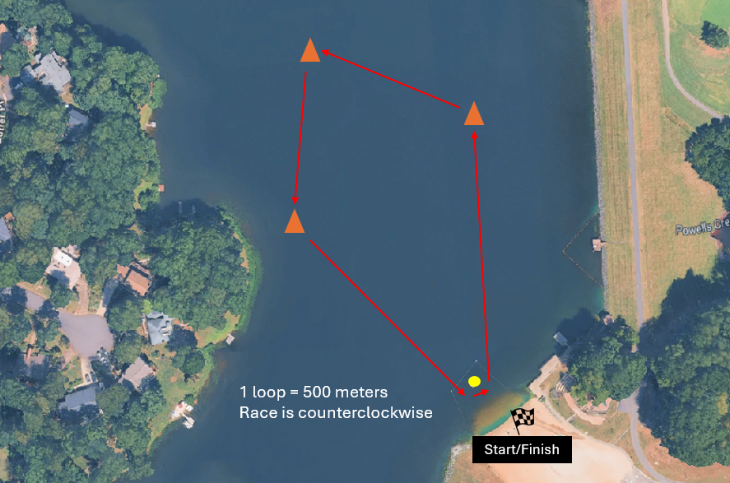

Splash & Dash
- RACES REQUIRE Check-In between 11:45 AM-12:30 PM (participation may be revoked without refund if late to registration).
  - Wave 1: 1 PM start for all Male Swimmers Ages 9-12
  - Wave 2: 1:15 PM start for all Female Swimmers Ages 9-12

